

Sri Lanka Institute of Information Technology

Information Technology Project (IT2080)

**Batch ID - WE.IT.04**

**Group ID - WE_B04_G04**

**EasyRent - Vehicle Rental and Hiring Management System**

Submitted by**:**

|  |  |  |  |  |
| --- | --- | --- | --- | --- |
|  | **Name with Initials**  **(Surname first)** | **Registration Number** | **Contact Phone Number** | **Email** |
|  | Jayasekara M.P.S.S | IT22580344 | 0772629286 | [it22580344@my.sliit.lk](mailto:it22580344@my.sliit.lk) |
|  | Chandrasekara C.M.P.V | IT22286246 | 0762404667 | [it22286246@my.sliit.lk](mailto:it22286246@my.sliit.lk) |
|  | Wijewantha H.D.C | IT22137128 | 0776183693 | [it22137128@my.sliit.lk](mailto:it22137128@my.sliit.lk) |
|  | Nathasha K.D.S | IT22230638 | 0703886818 | [it22230638@my.sliit.lk](mailto:it22230638@my.sliit.lk) |
|  | Jayasundara J.M.T.P | IT22281128 | 0786414979 | [it22281128@my.sliit.lk](mailto:it22281128@my.sliit.lk) |
|  | Tharuka M.S | IT22101242 | 0701215676 | [it22101242@my.sliit.lk](mailto:it22101242@my.sliit.lk) |
|  | Silva M.W.P.R.K | IT22124876 | 0777372445 | [it22124876@my.sliit.lk](mailto:it22124876@my.sliit.lk) |
|  | Abeysekara W.R.G.M | IT22271150 | 0776501141 | [it22271150@my.sliit.lk](mailto:it22271150@my.sliit.lk) |

# Driver Management

## Activity Diagram

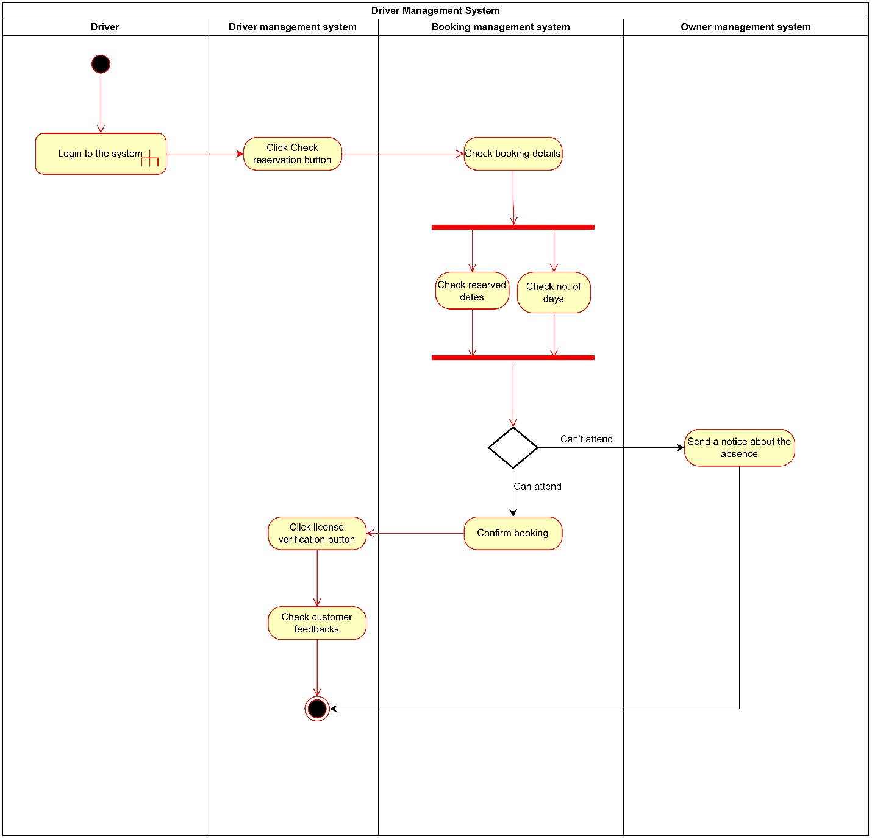

## Sequence Diagram

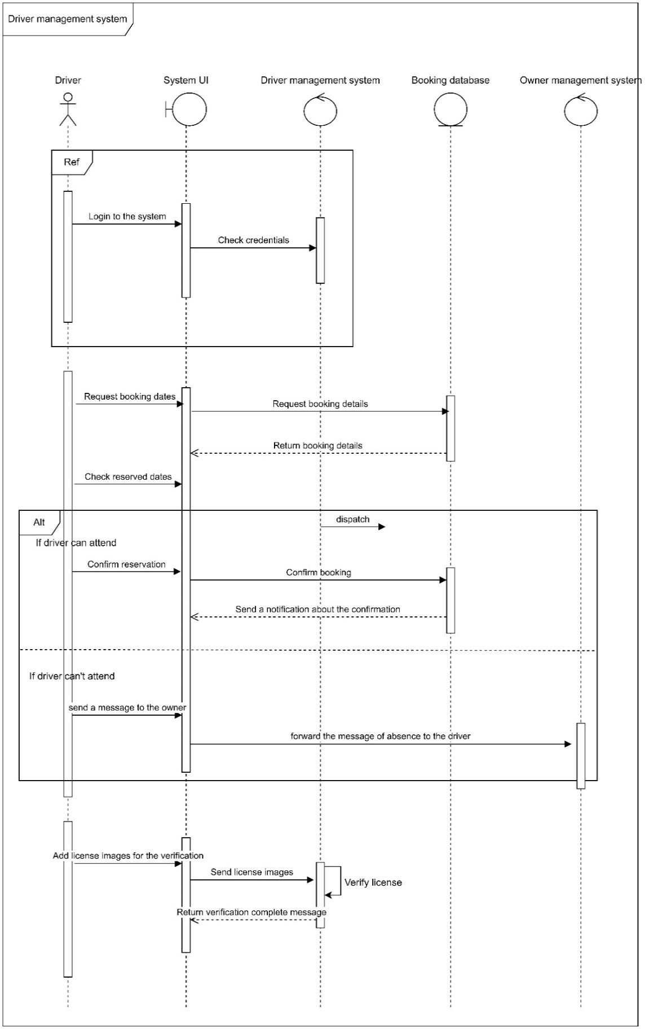

## User Interface

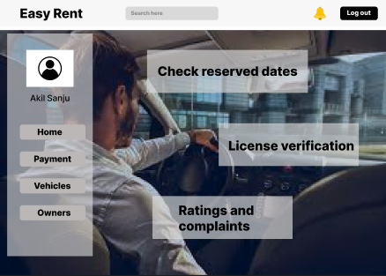

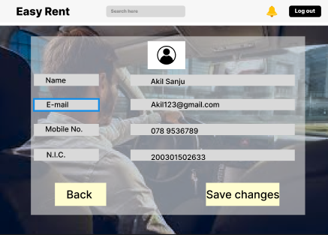

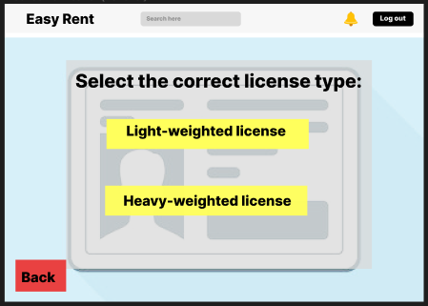

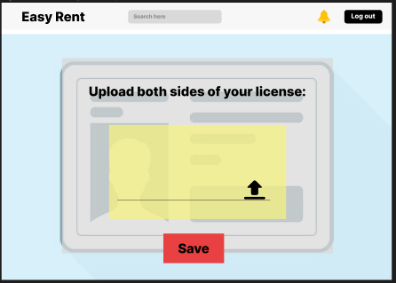

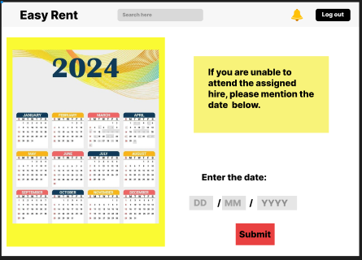

# Vehicle Owner Management

## Activity Diagram

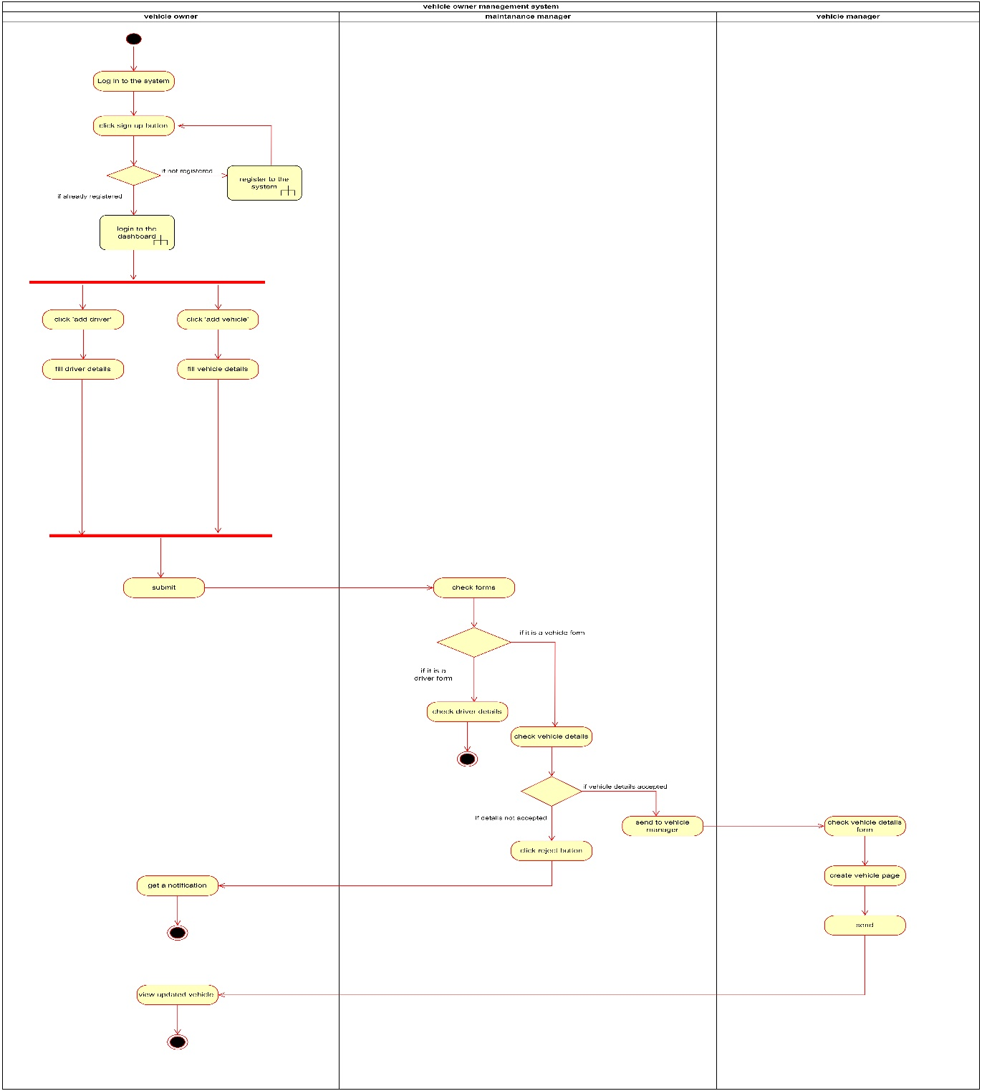

## Sequence Diagram

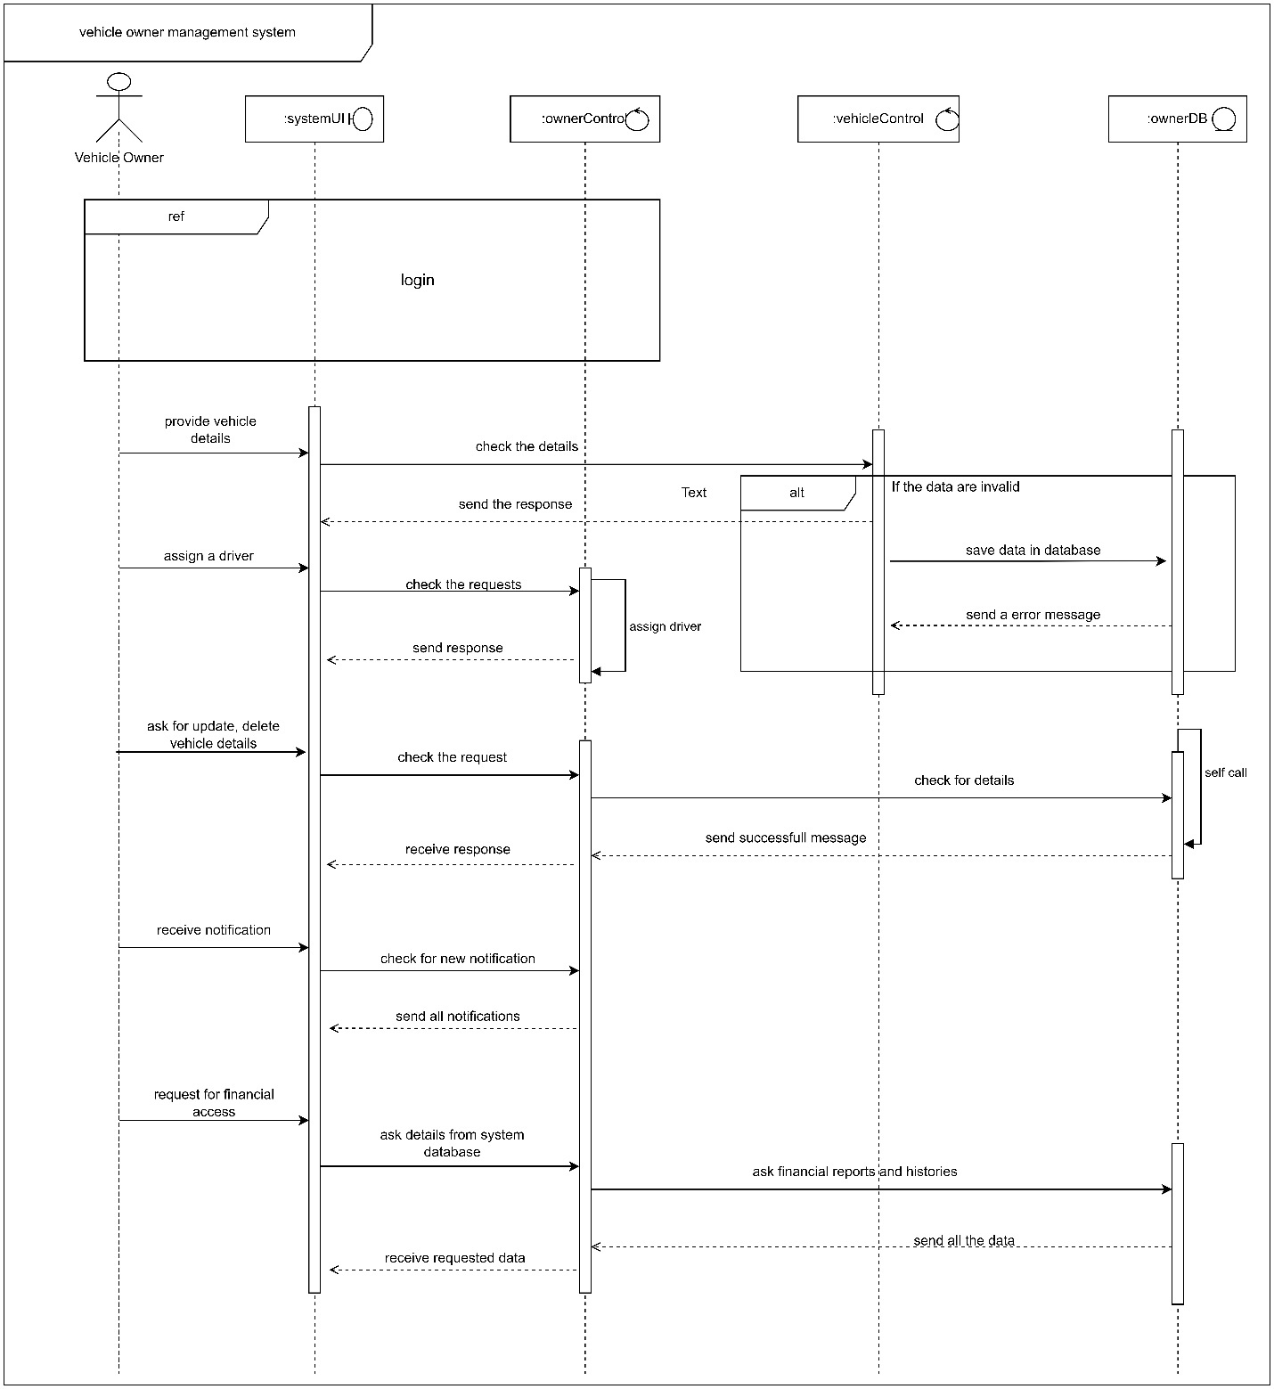

**

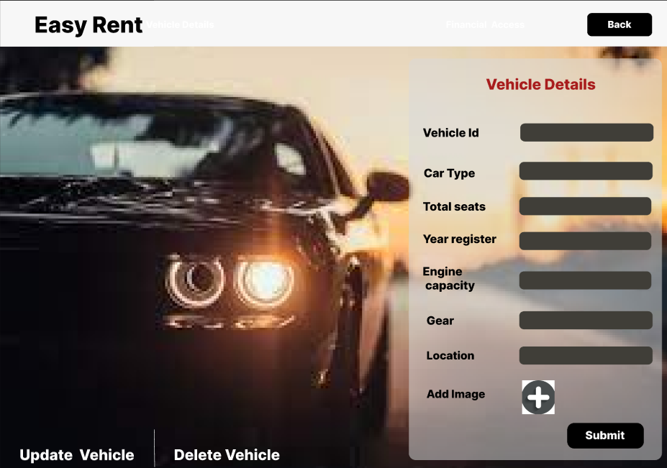



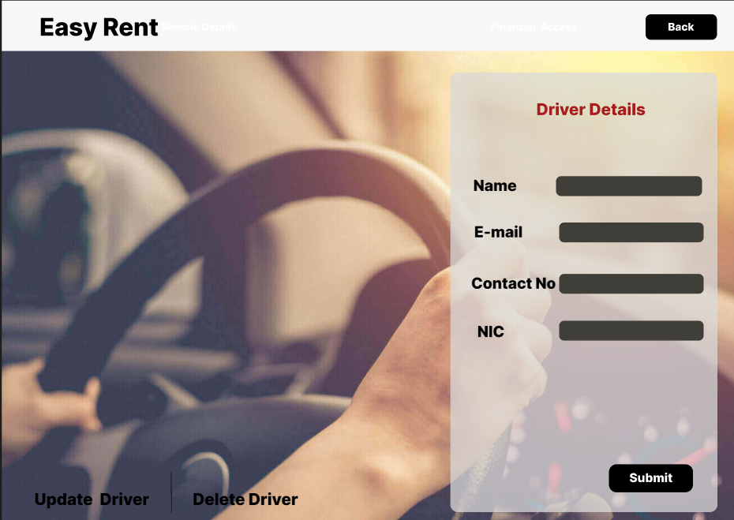

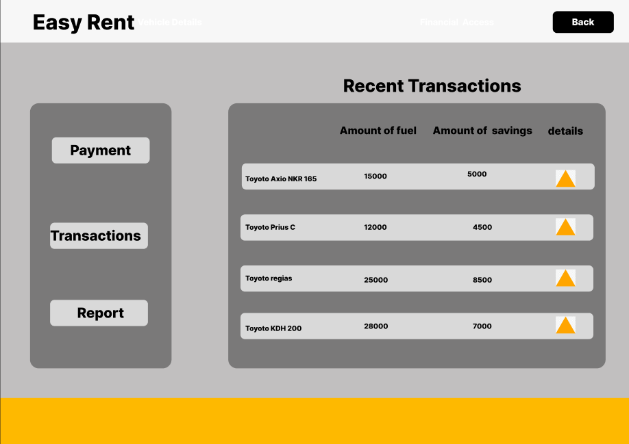

# Renter Management

## Activity Diagram

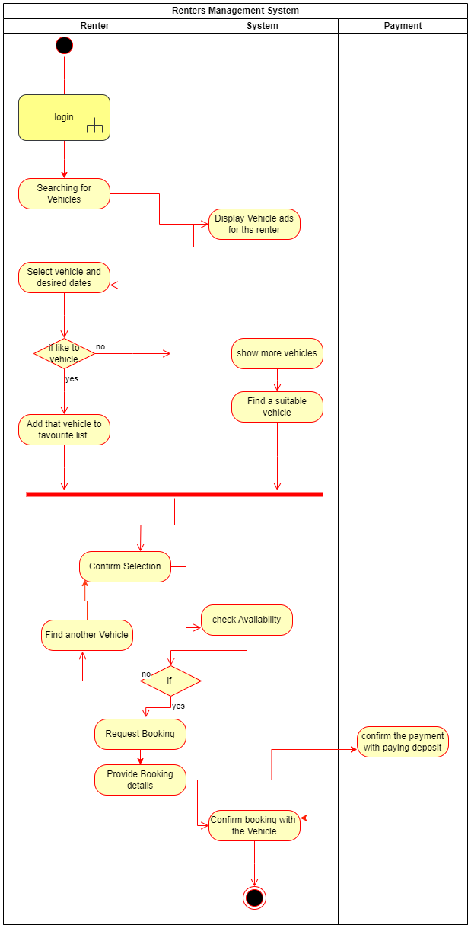

## Sequence Diagram

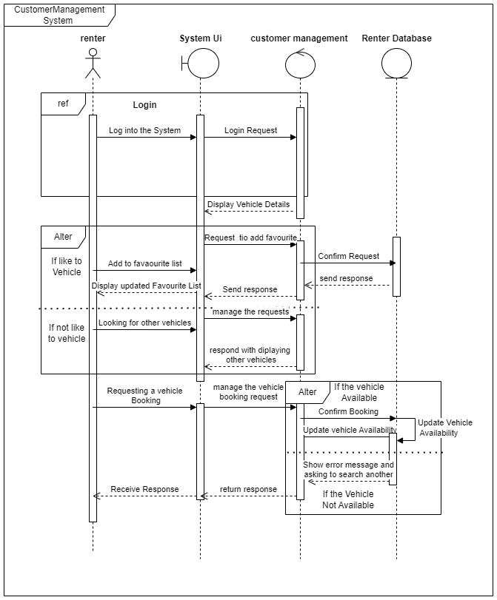

## User Interface

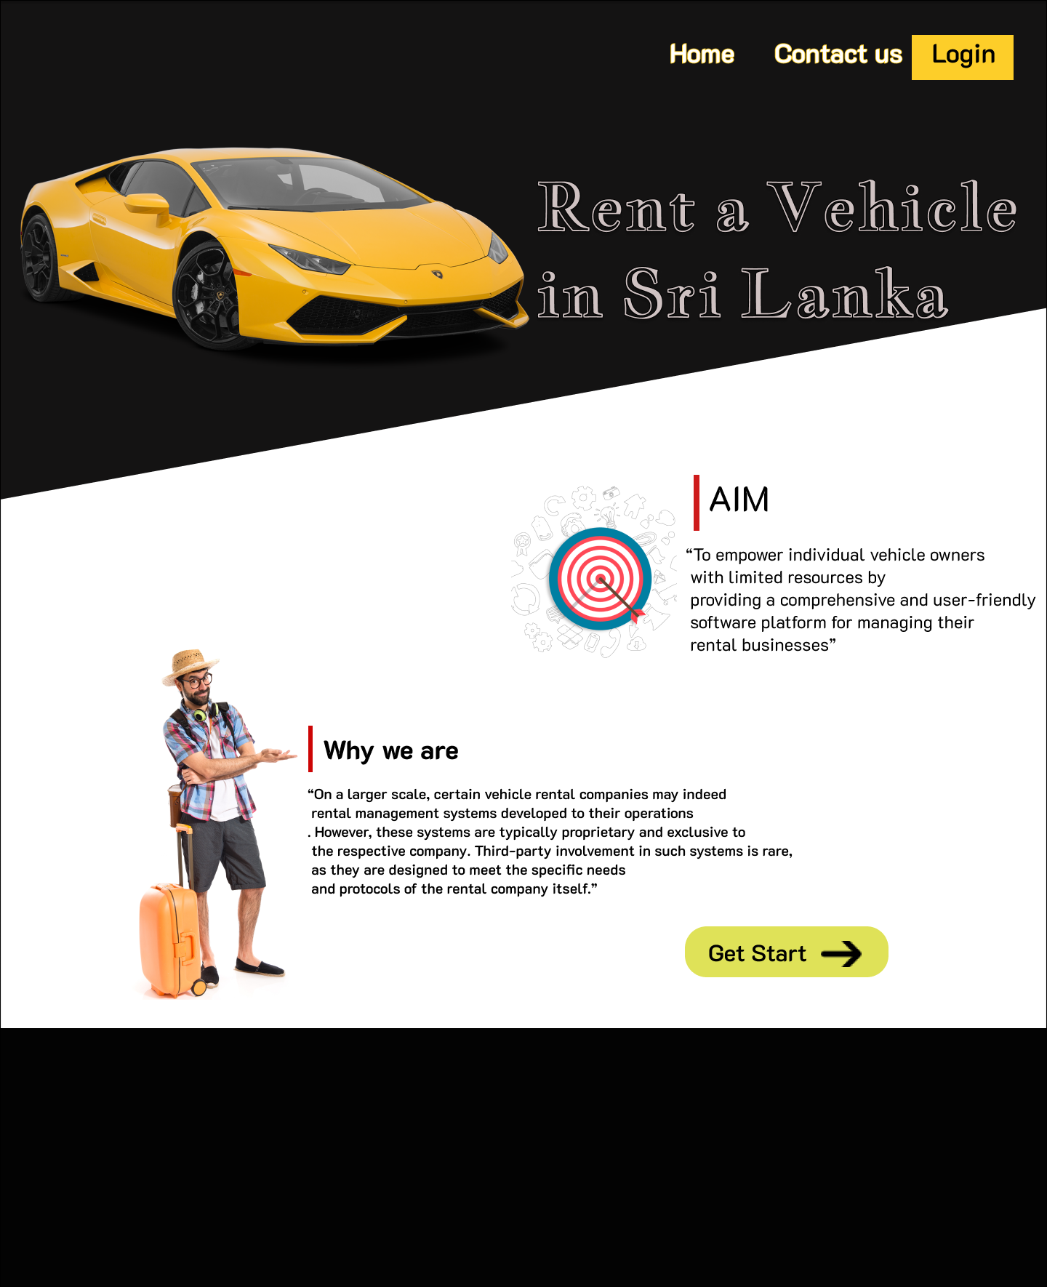

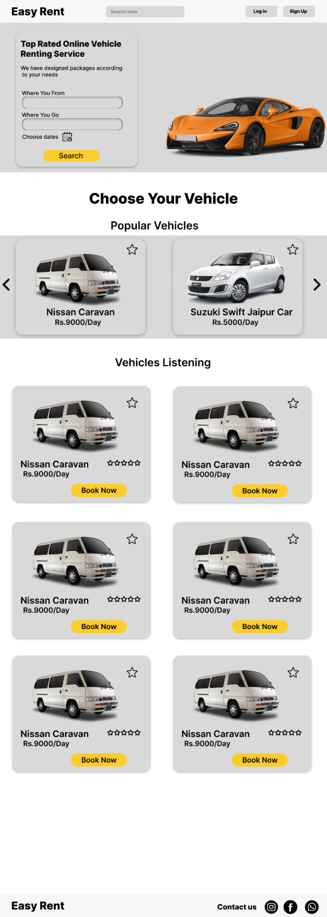

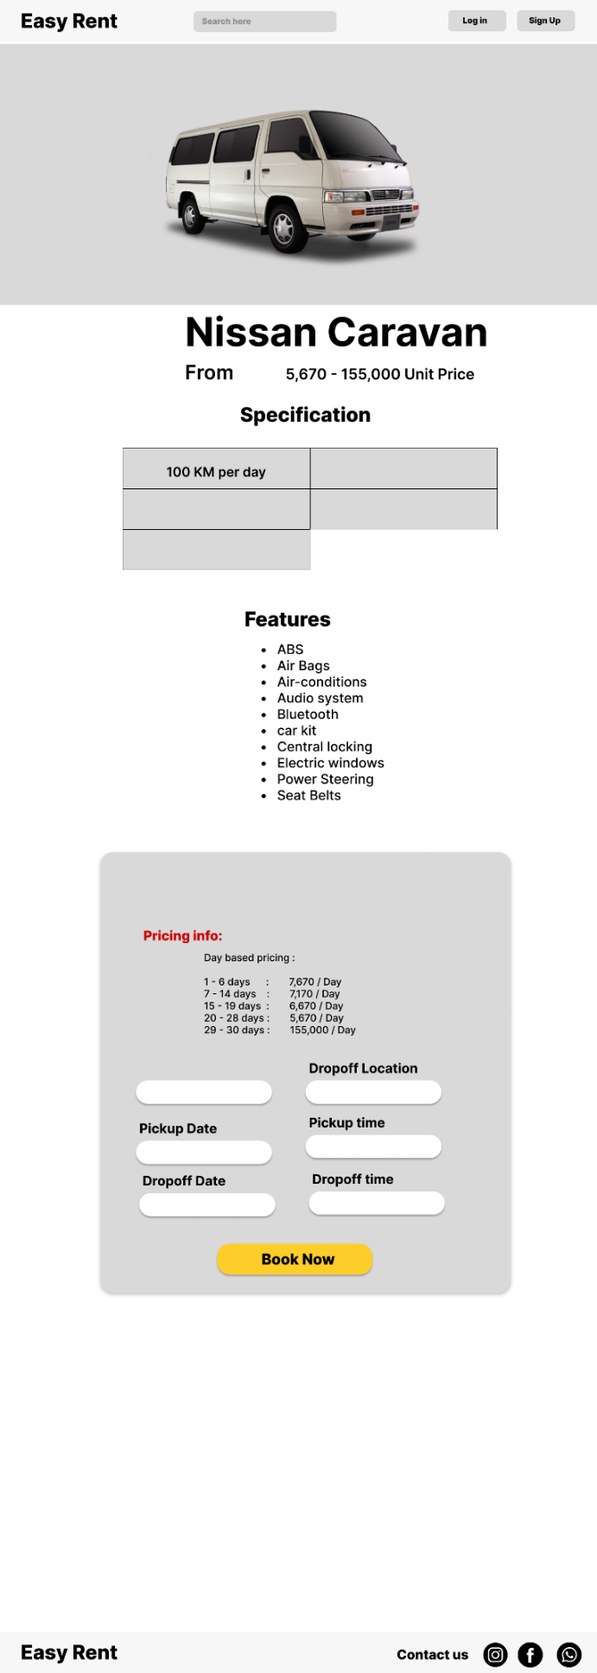

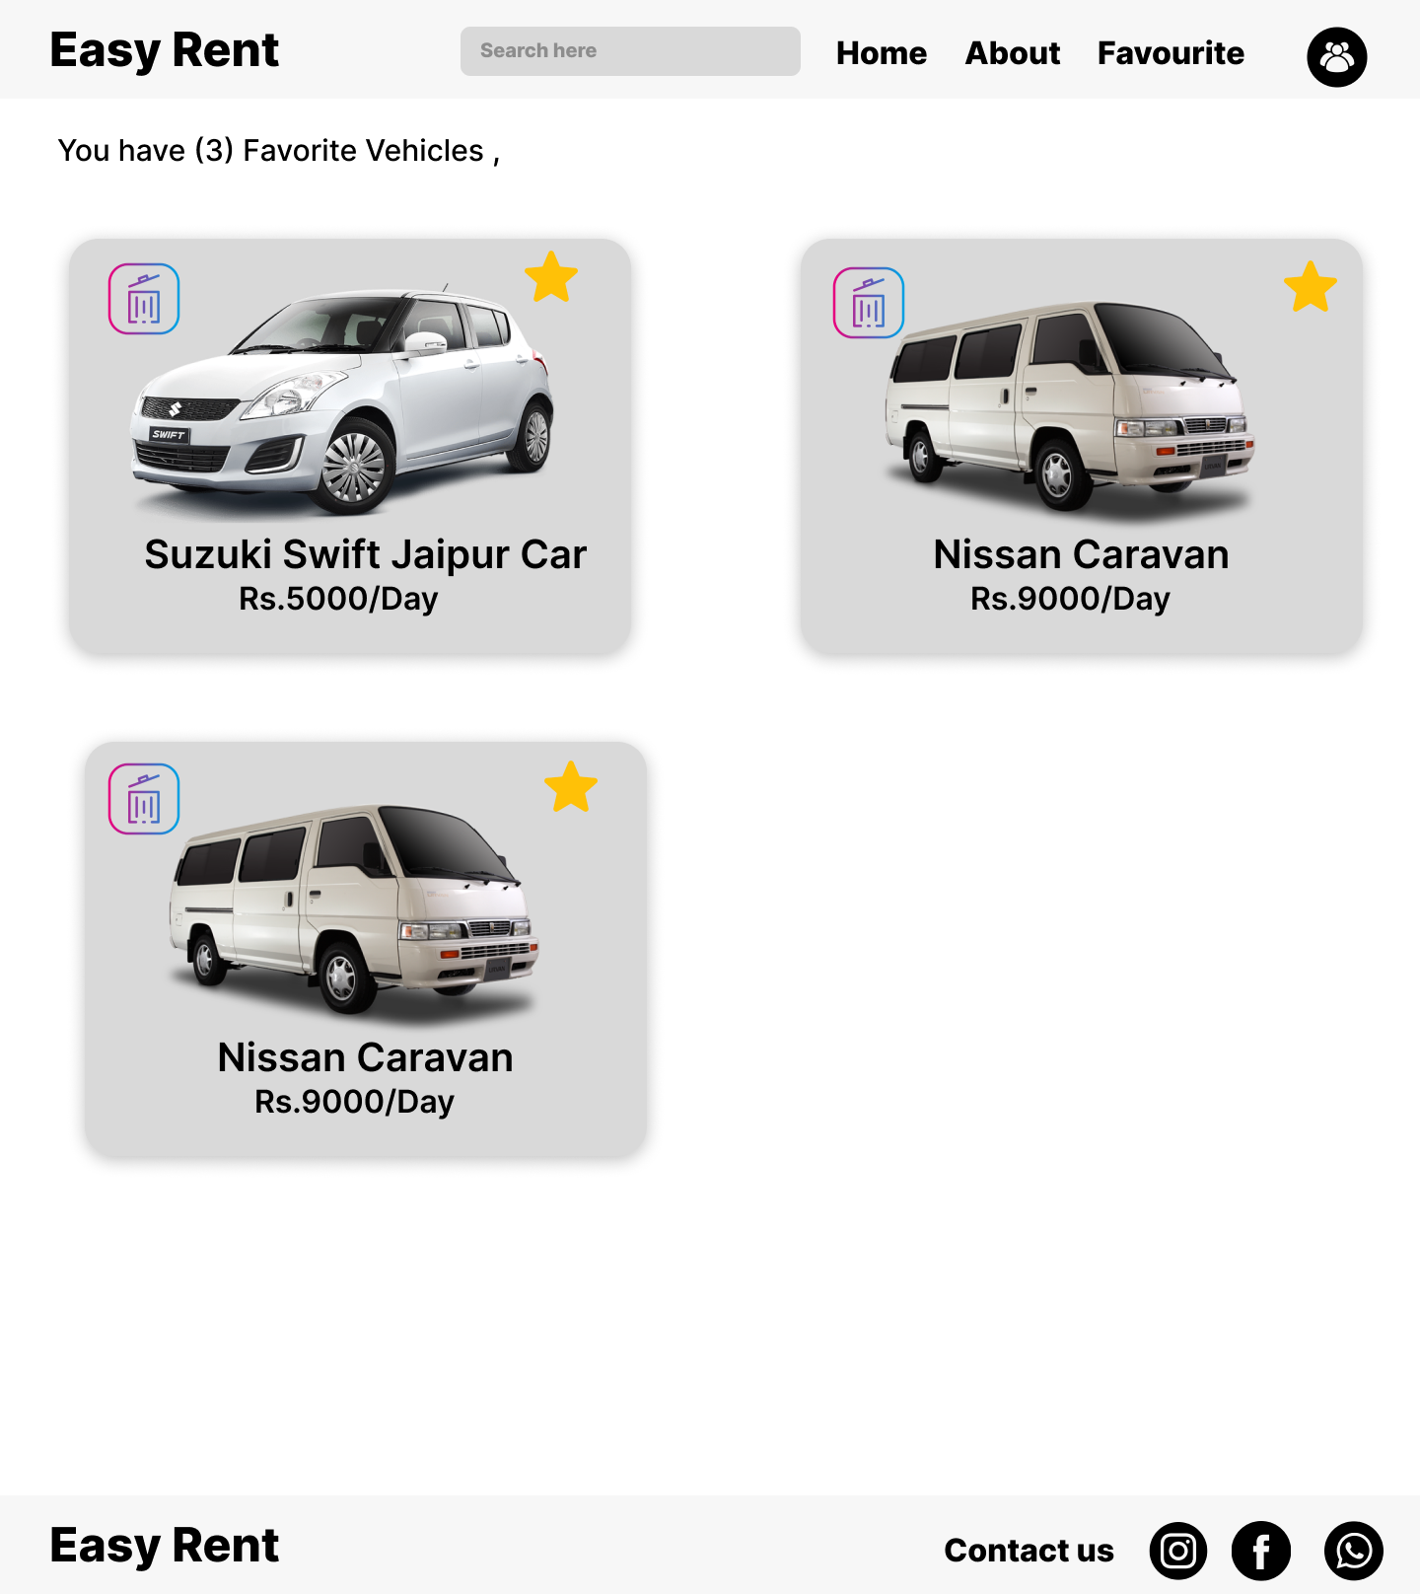

# Booking And Payment Management

## Booking Activity Diagram

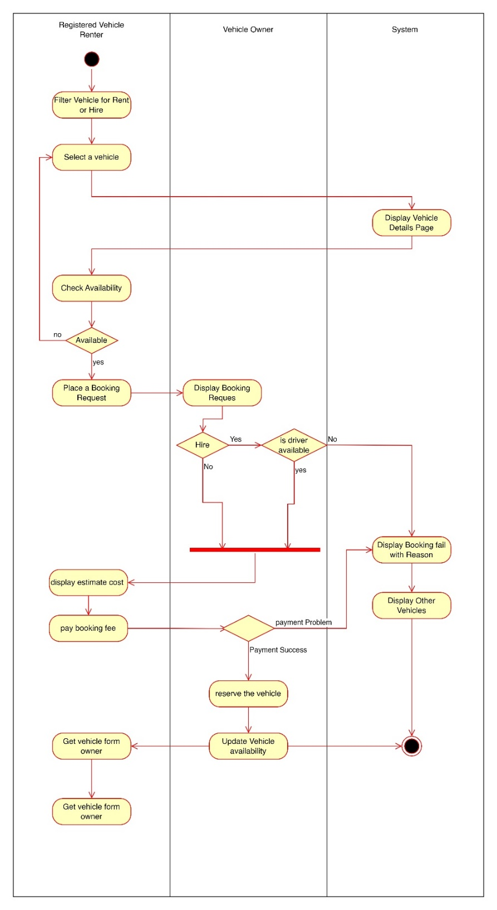

## Payment Activity Diagram

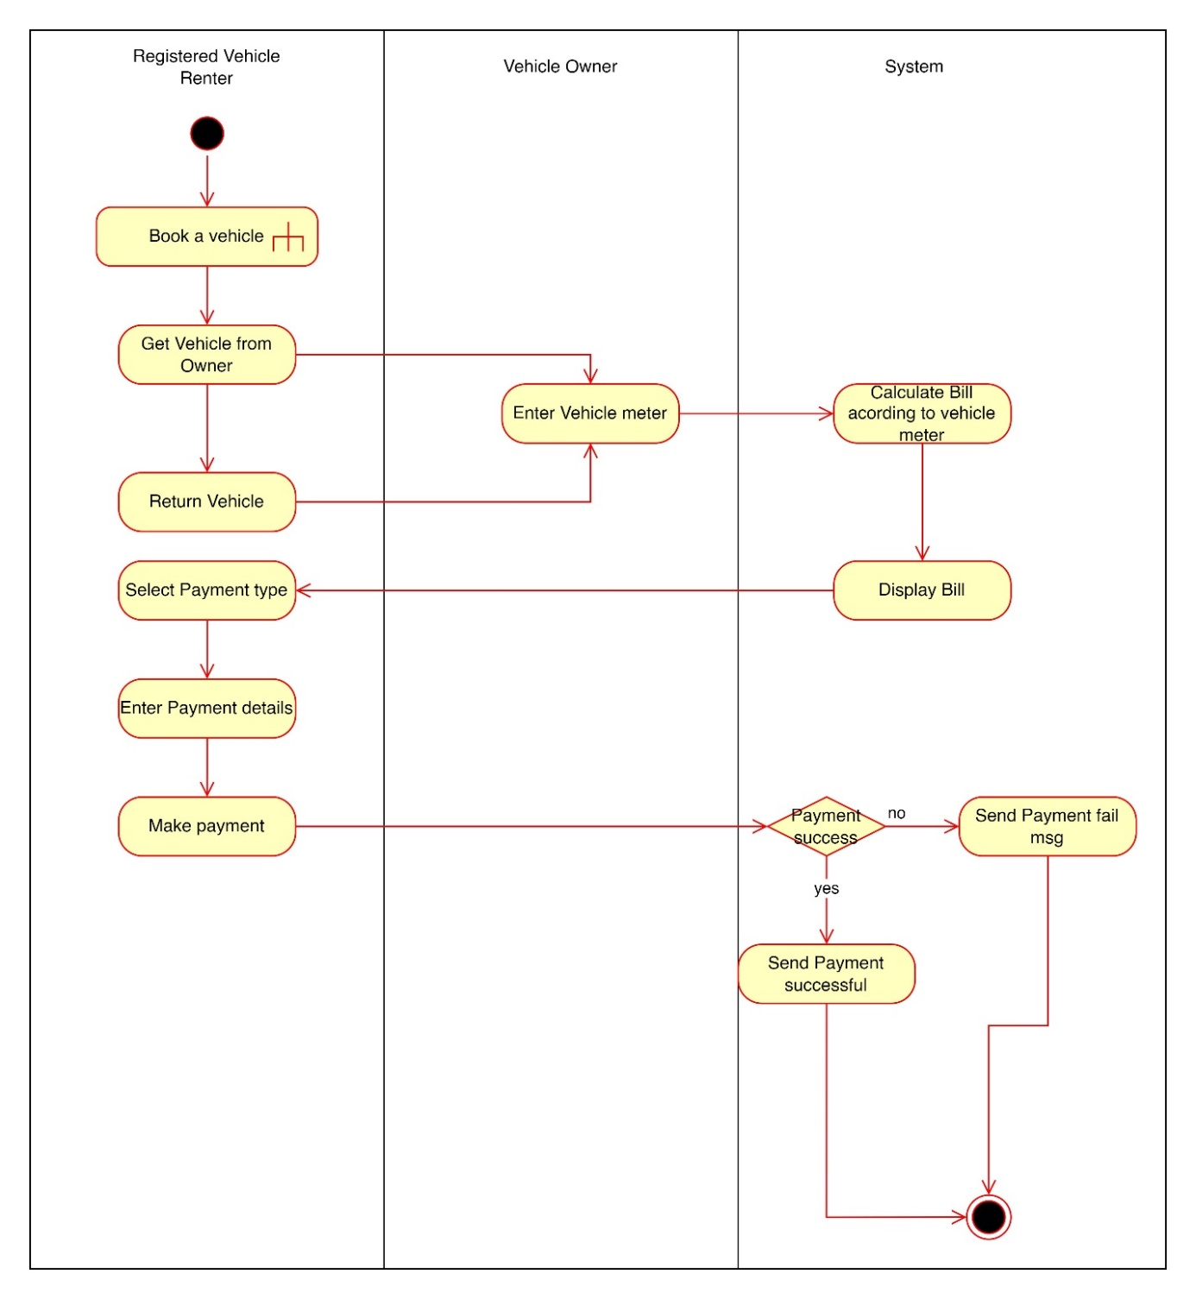

## Sequence Diagram

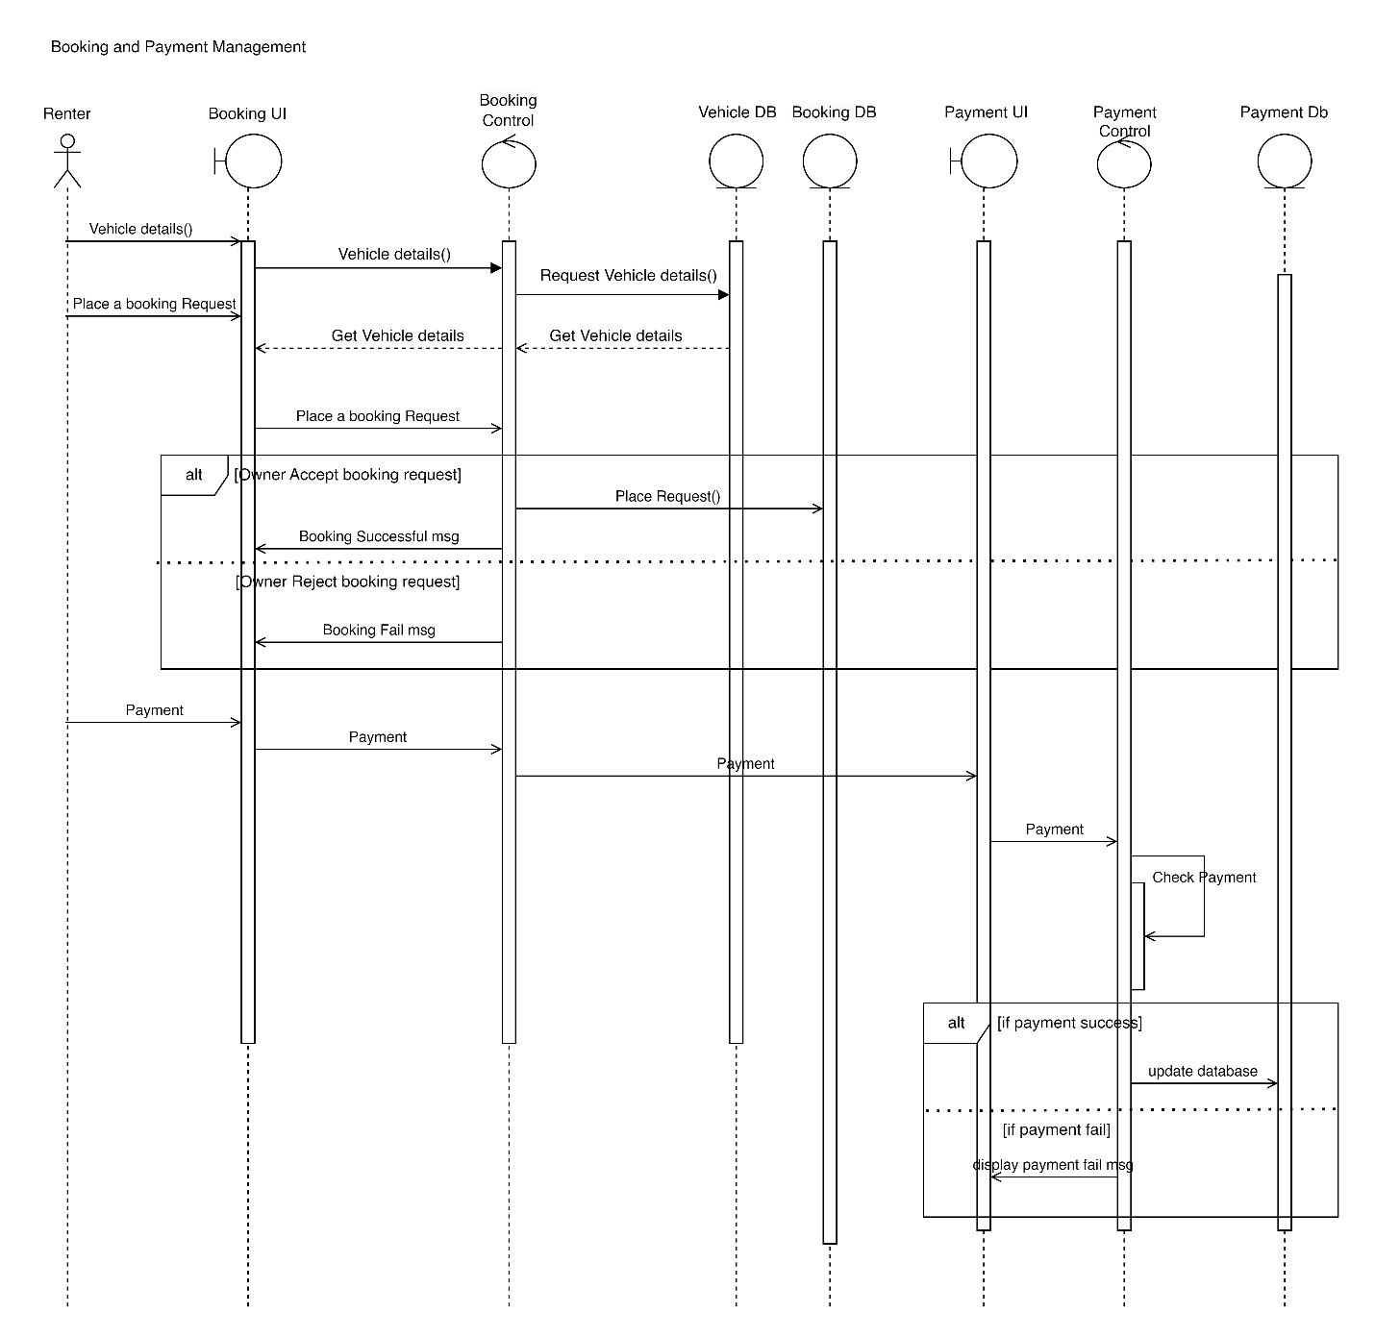

## User Interface

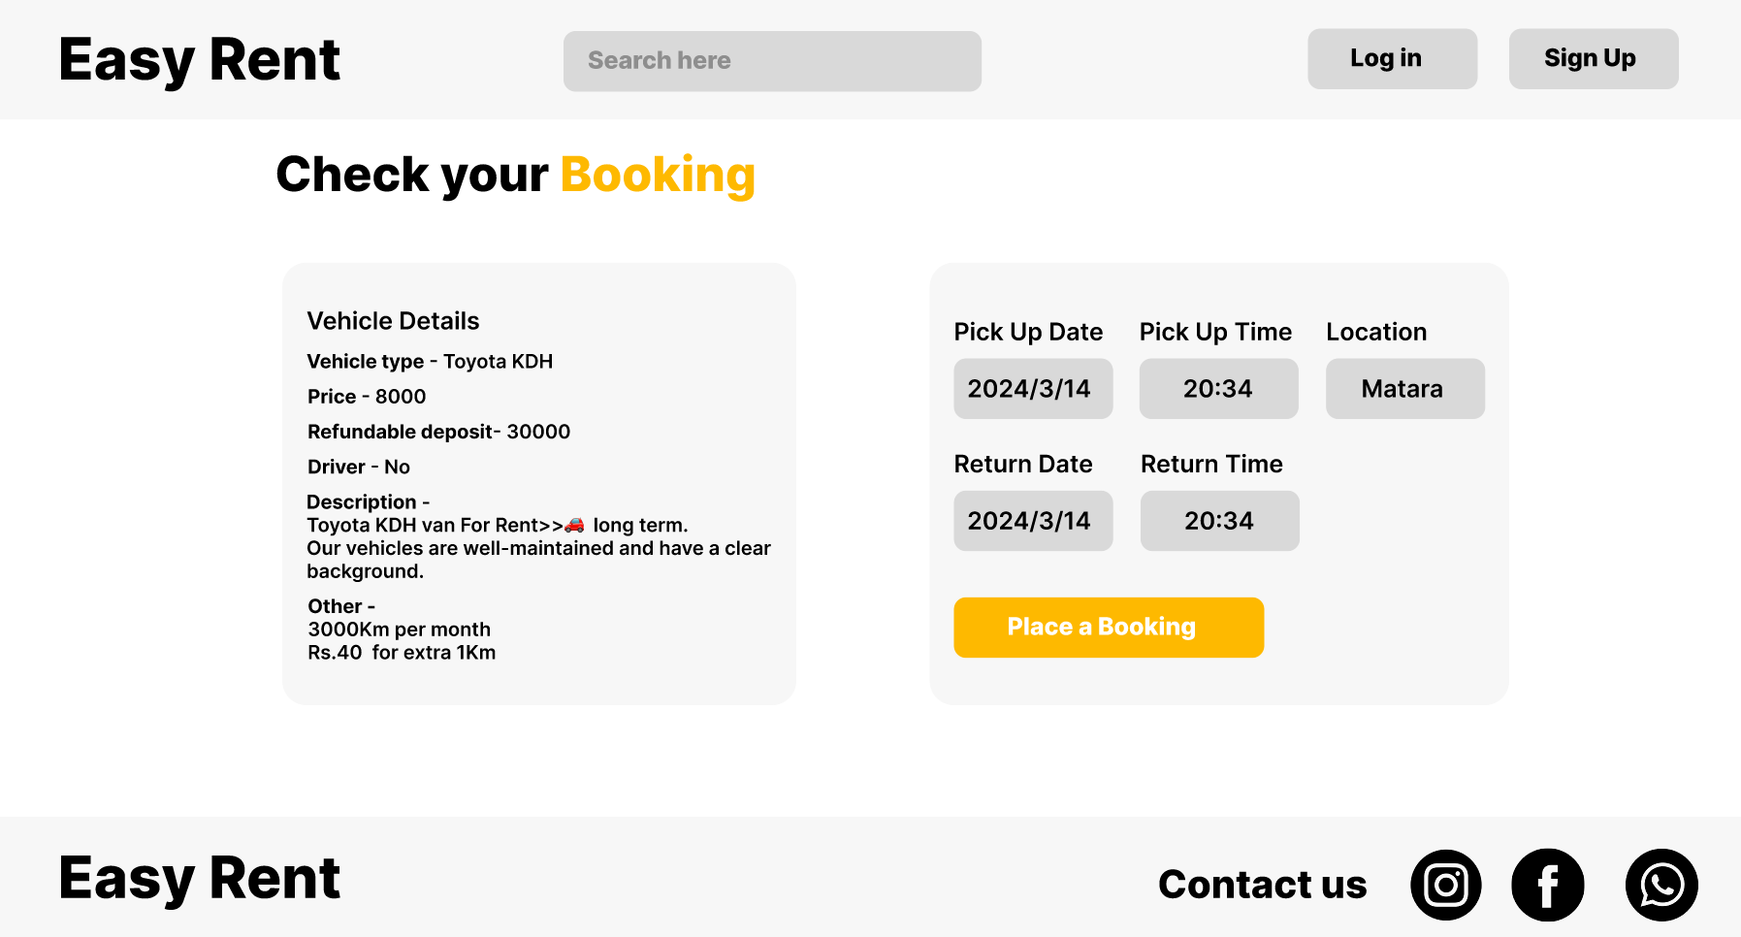

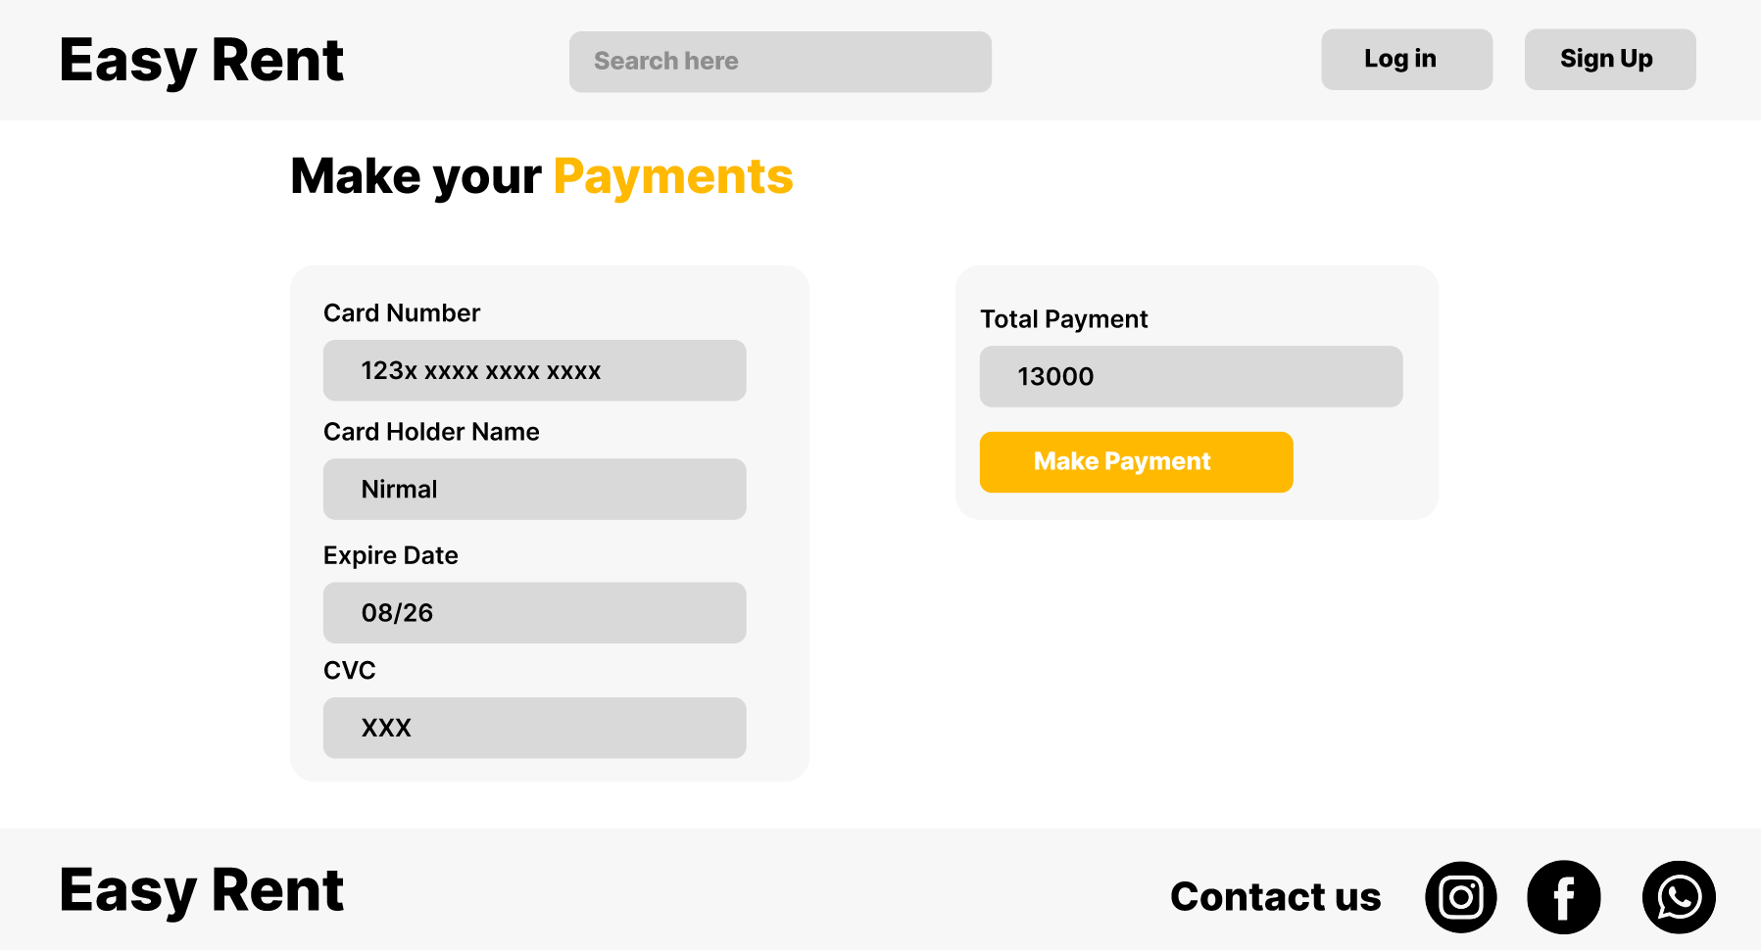

# Reviews and rating management

## Activity Diagram

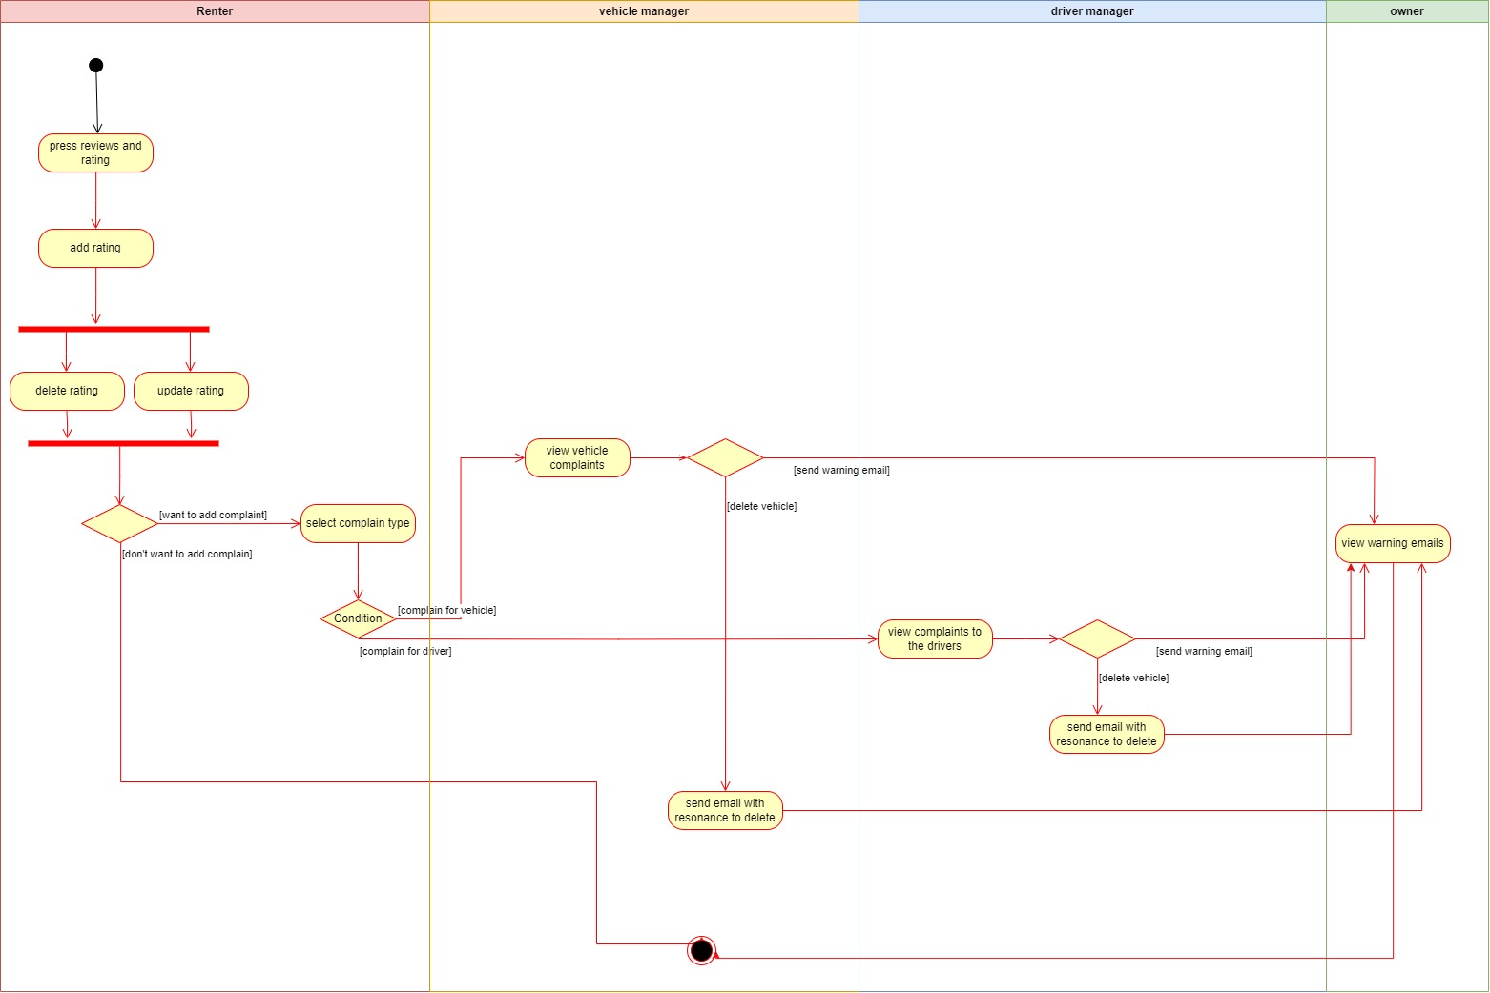

## Sequence-diagram

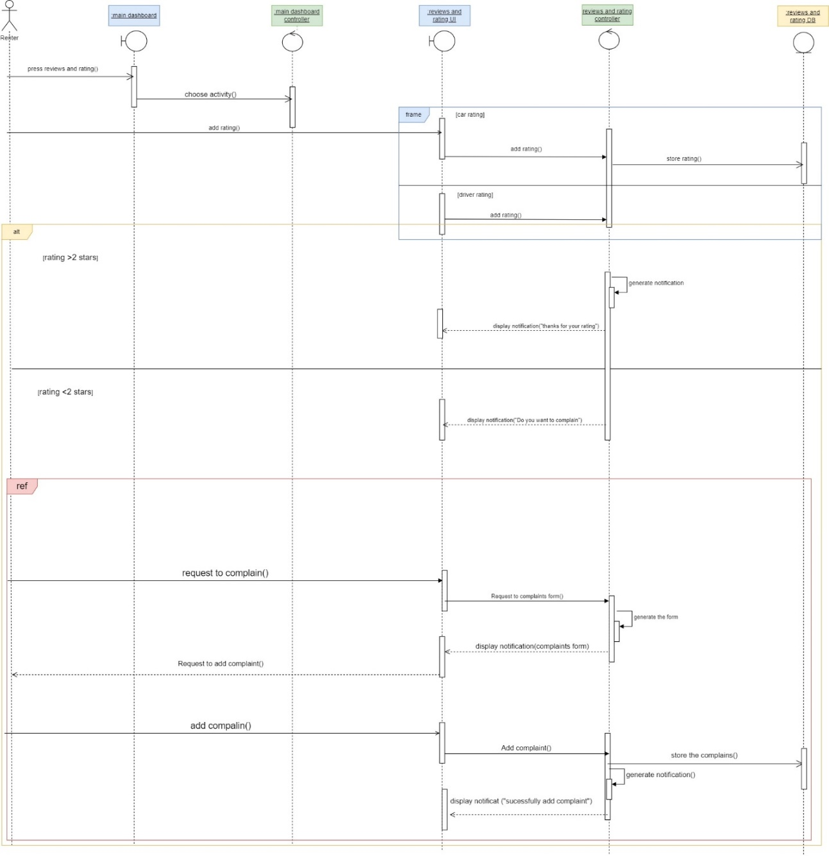

## User Interface

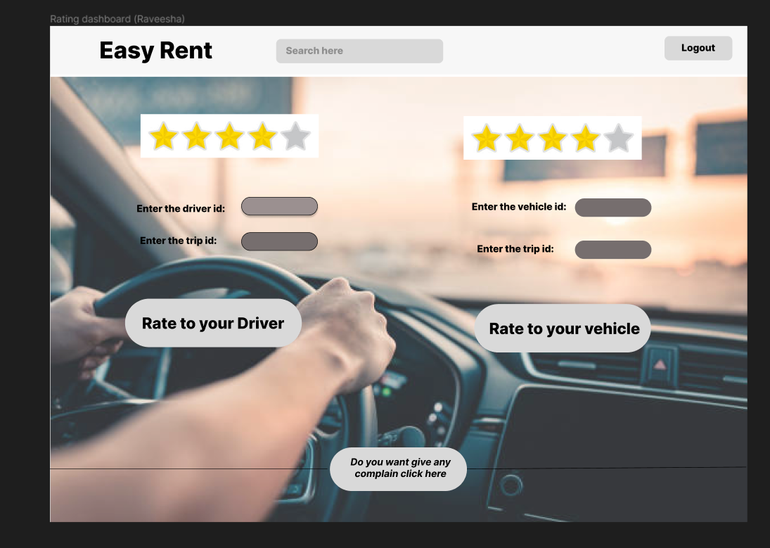

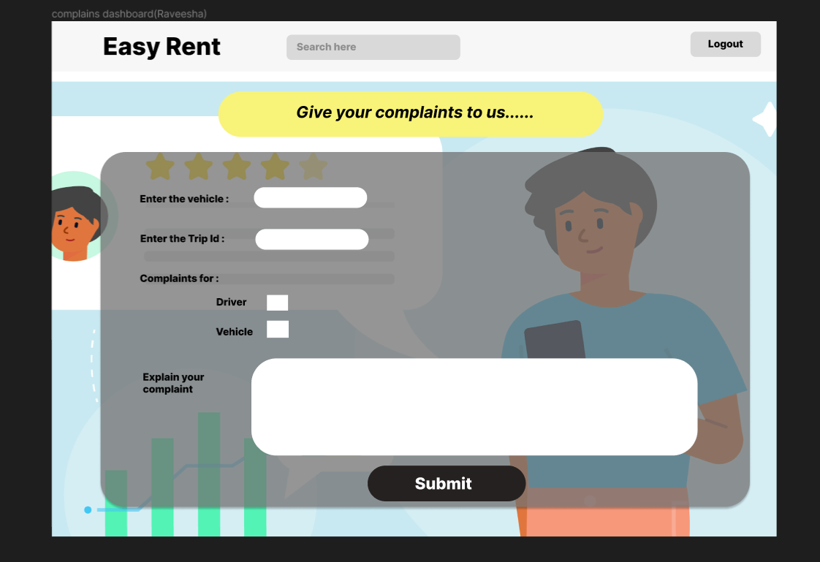

# Vehicle Management

## Activity Diagram

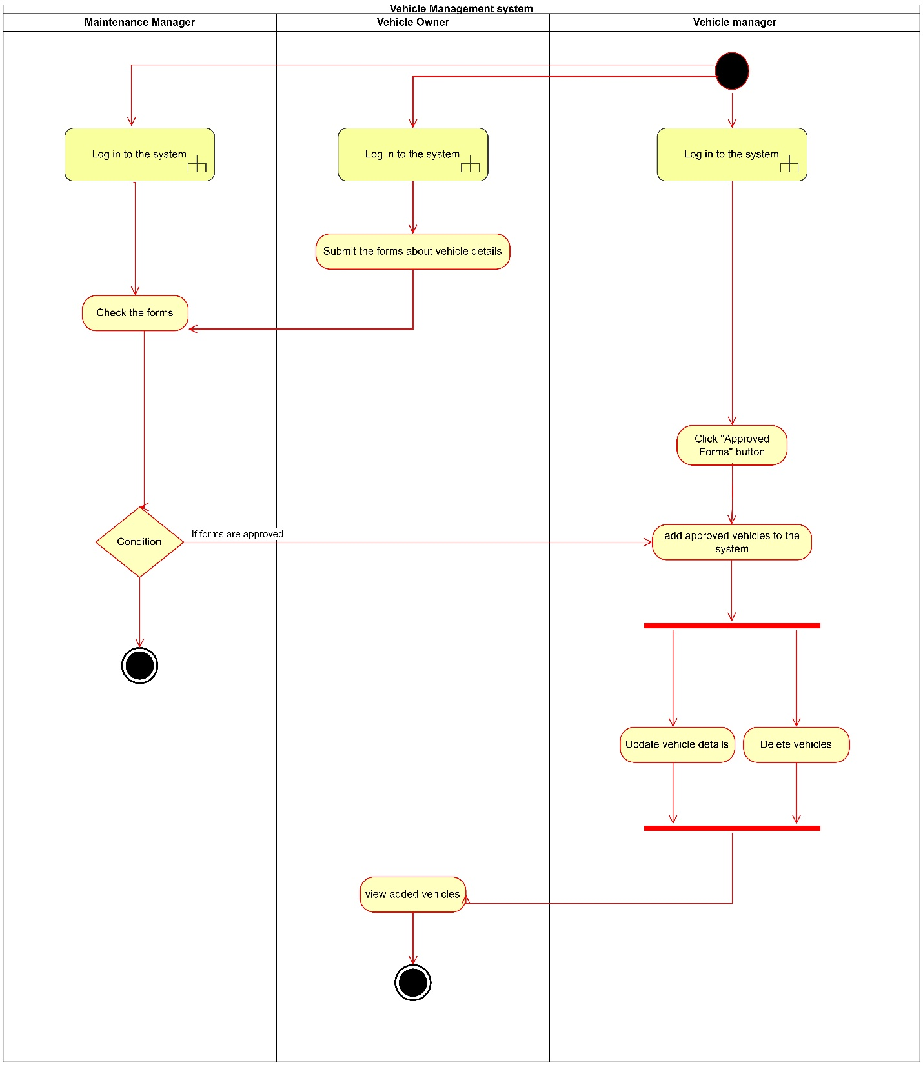

## Sequence diagram

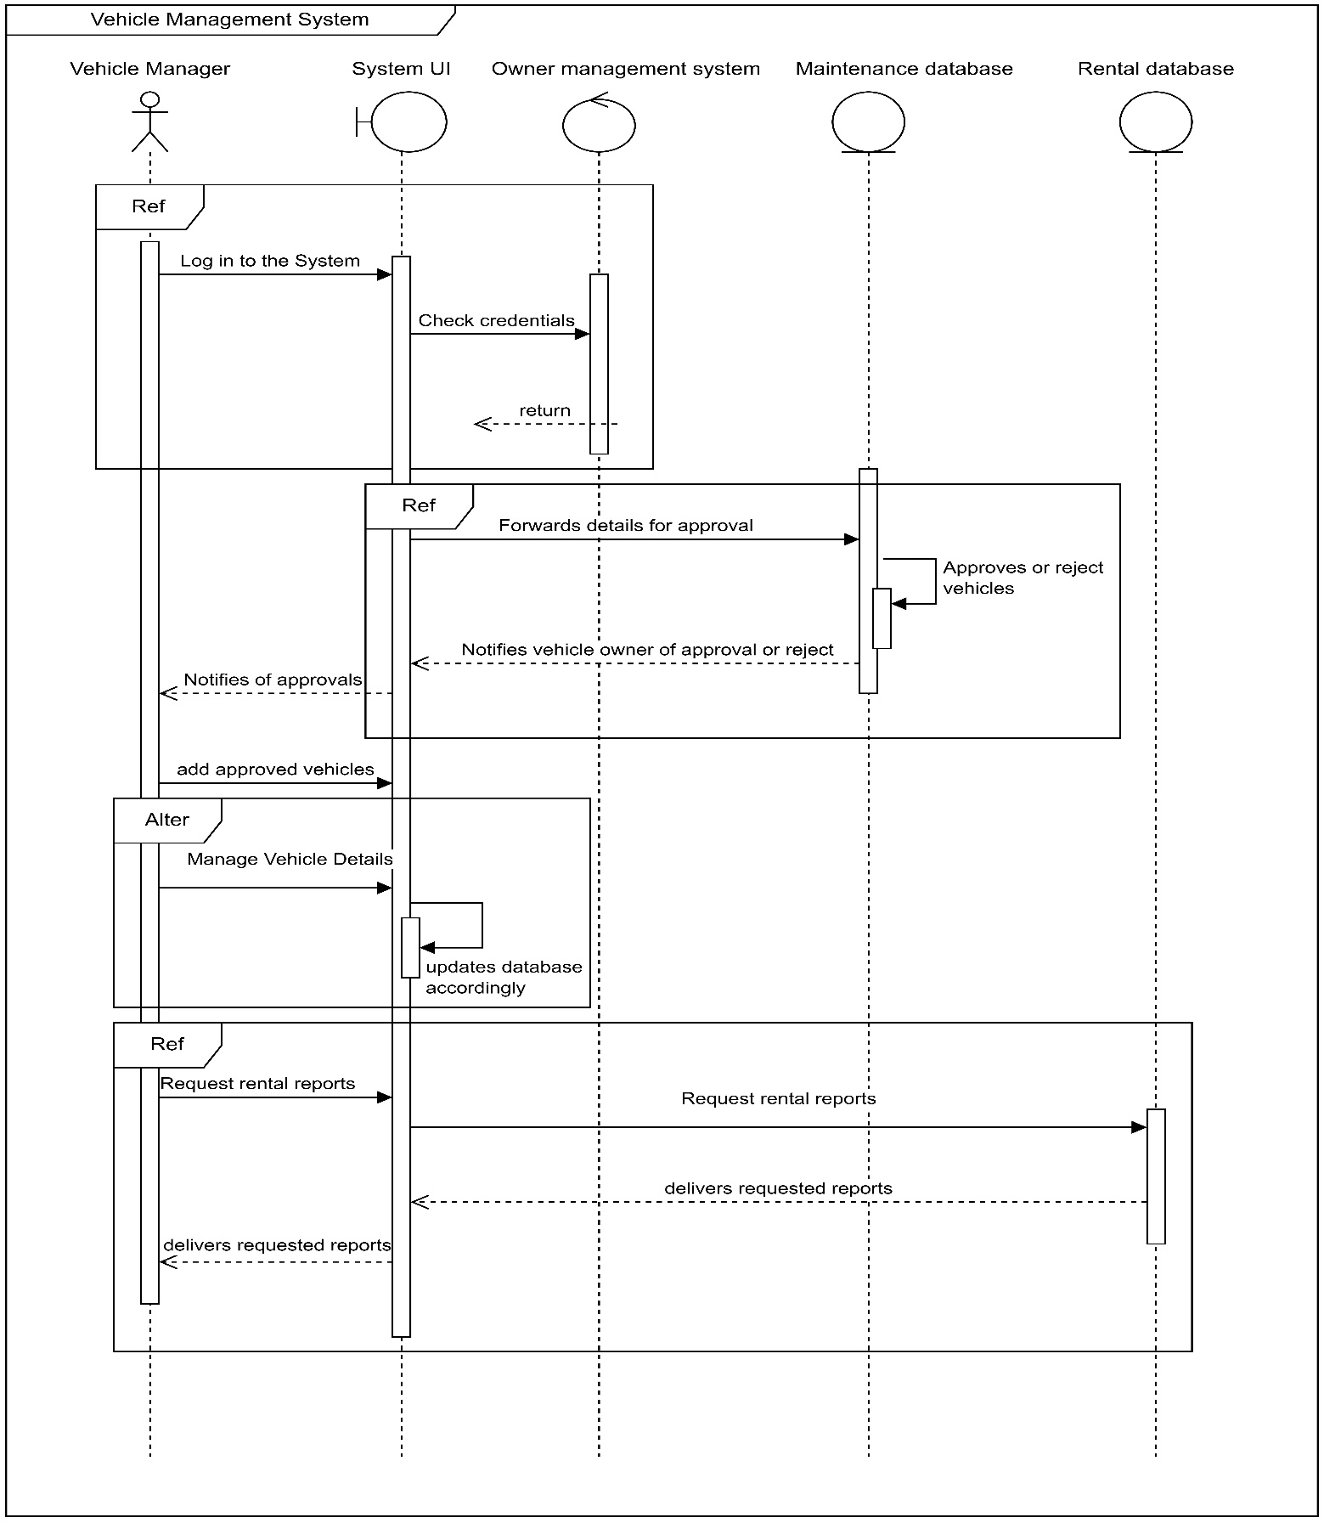

## User Interface

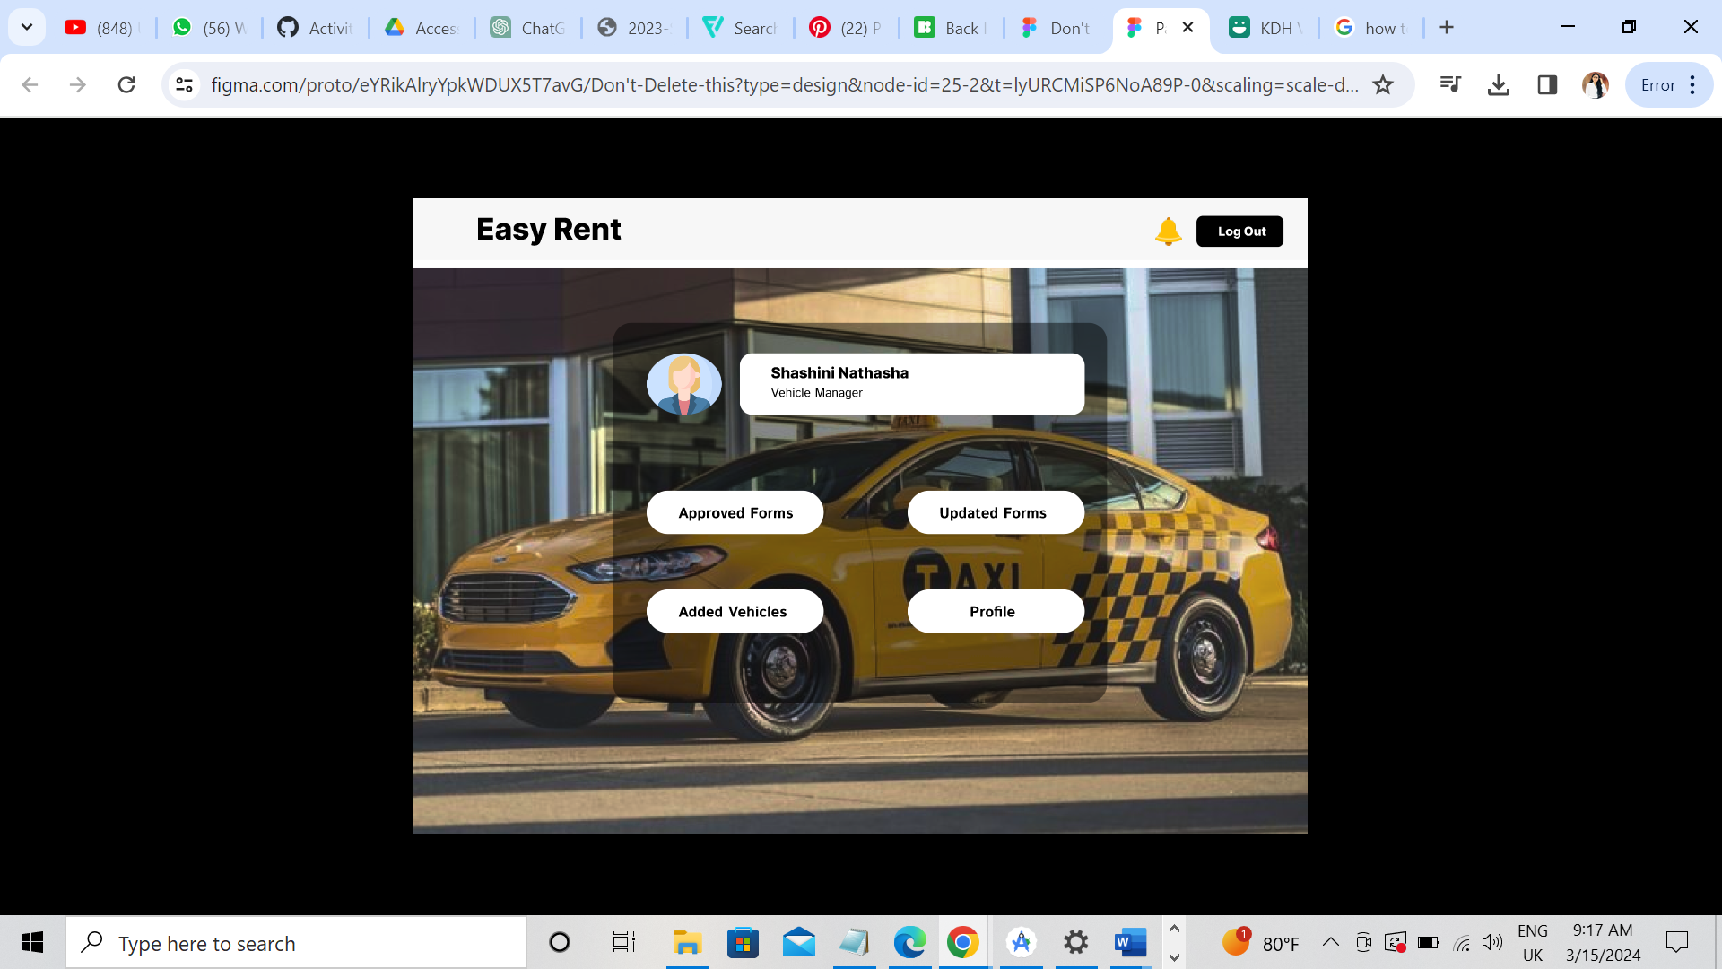

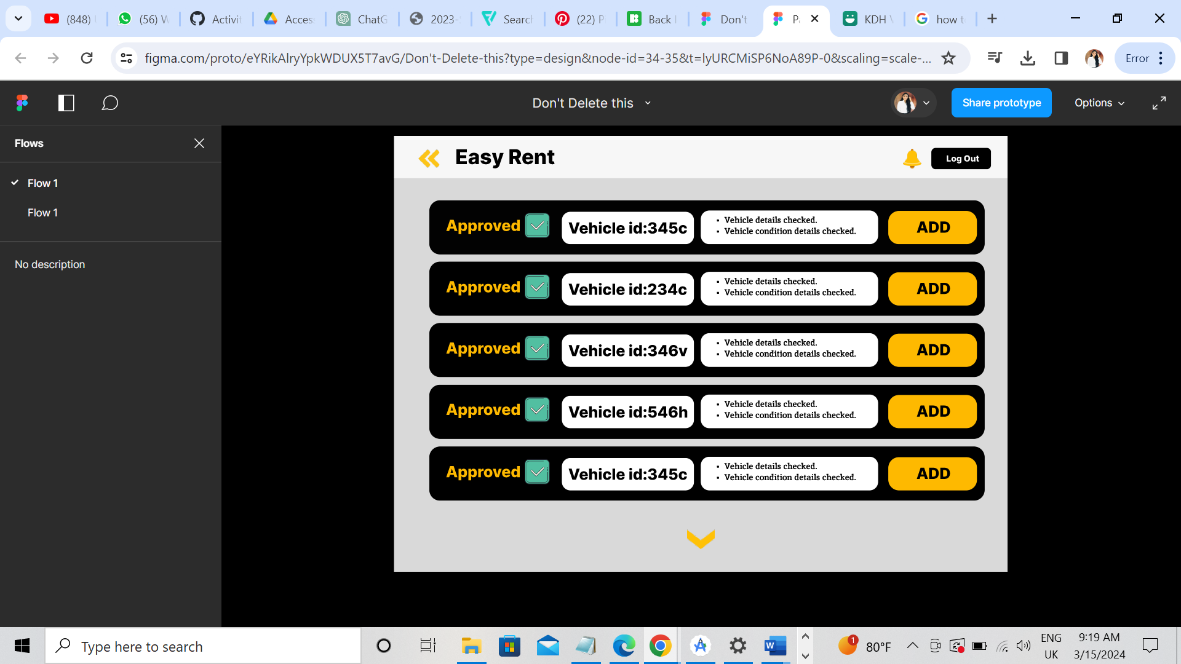

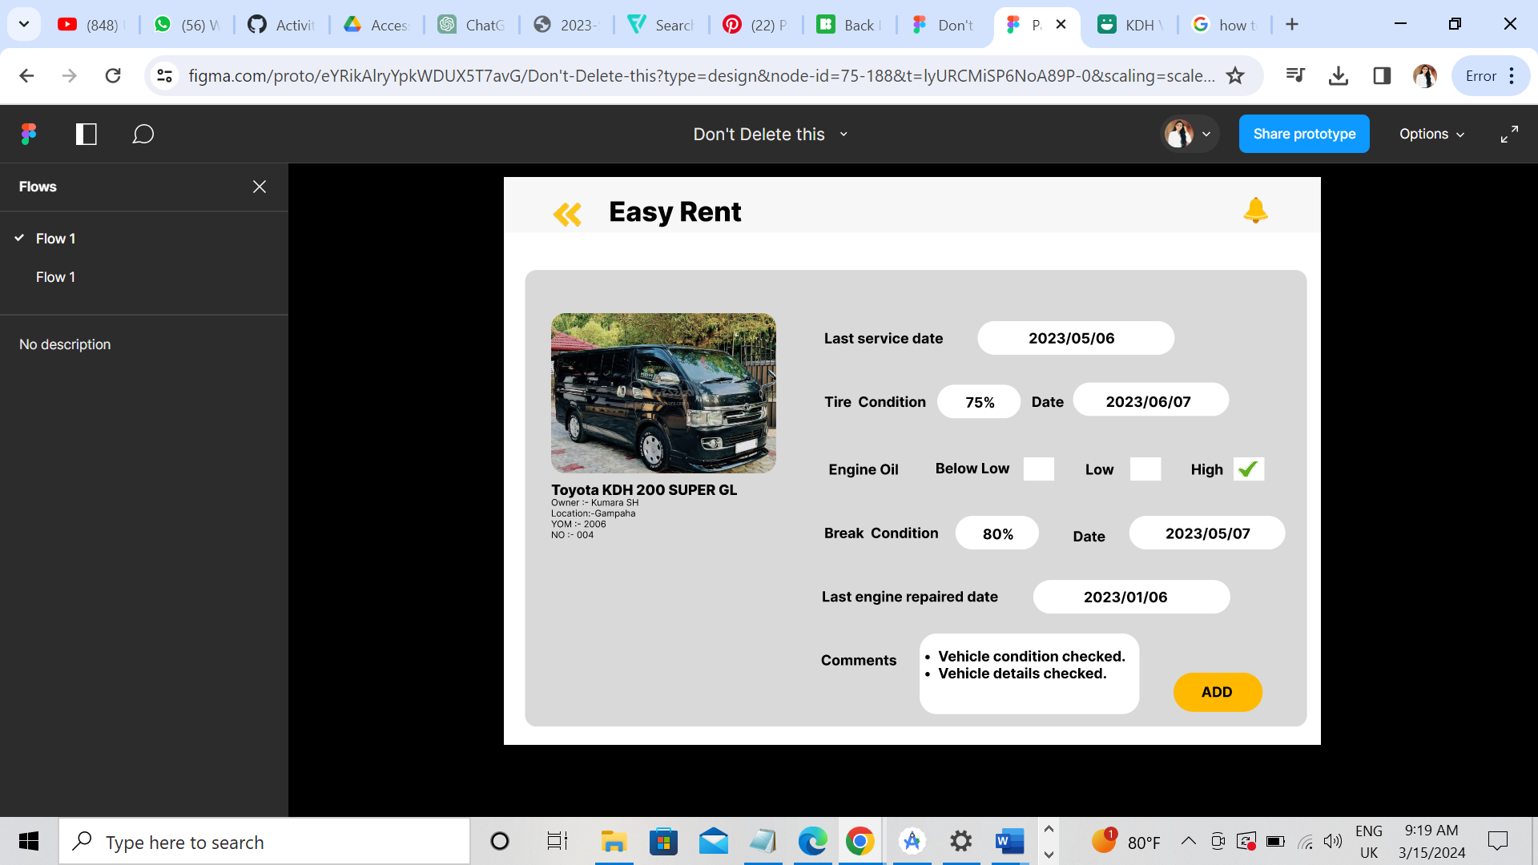

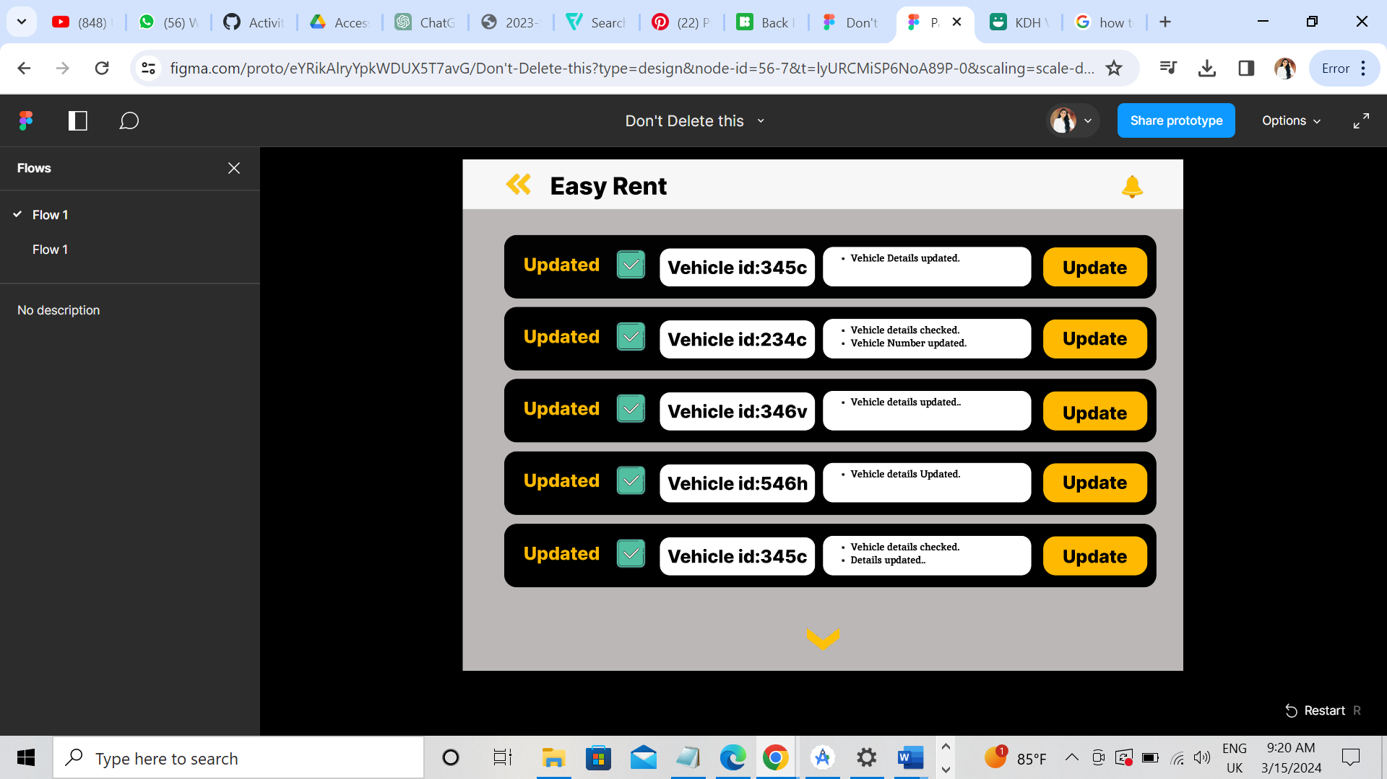

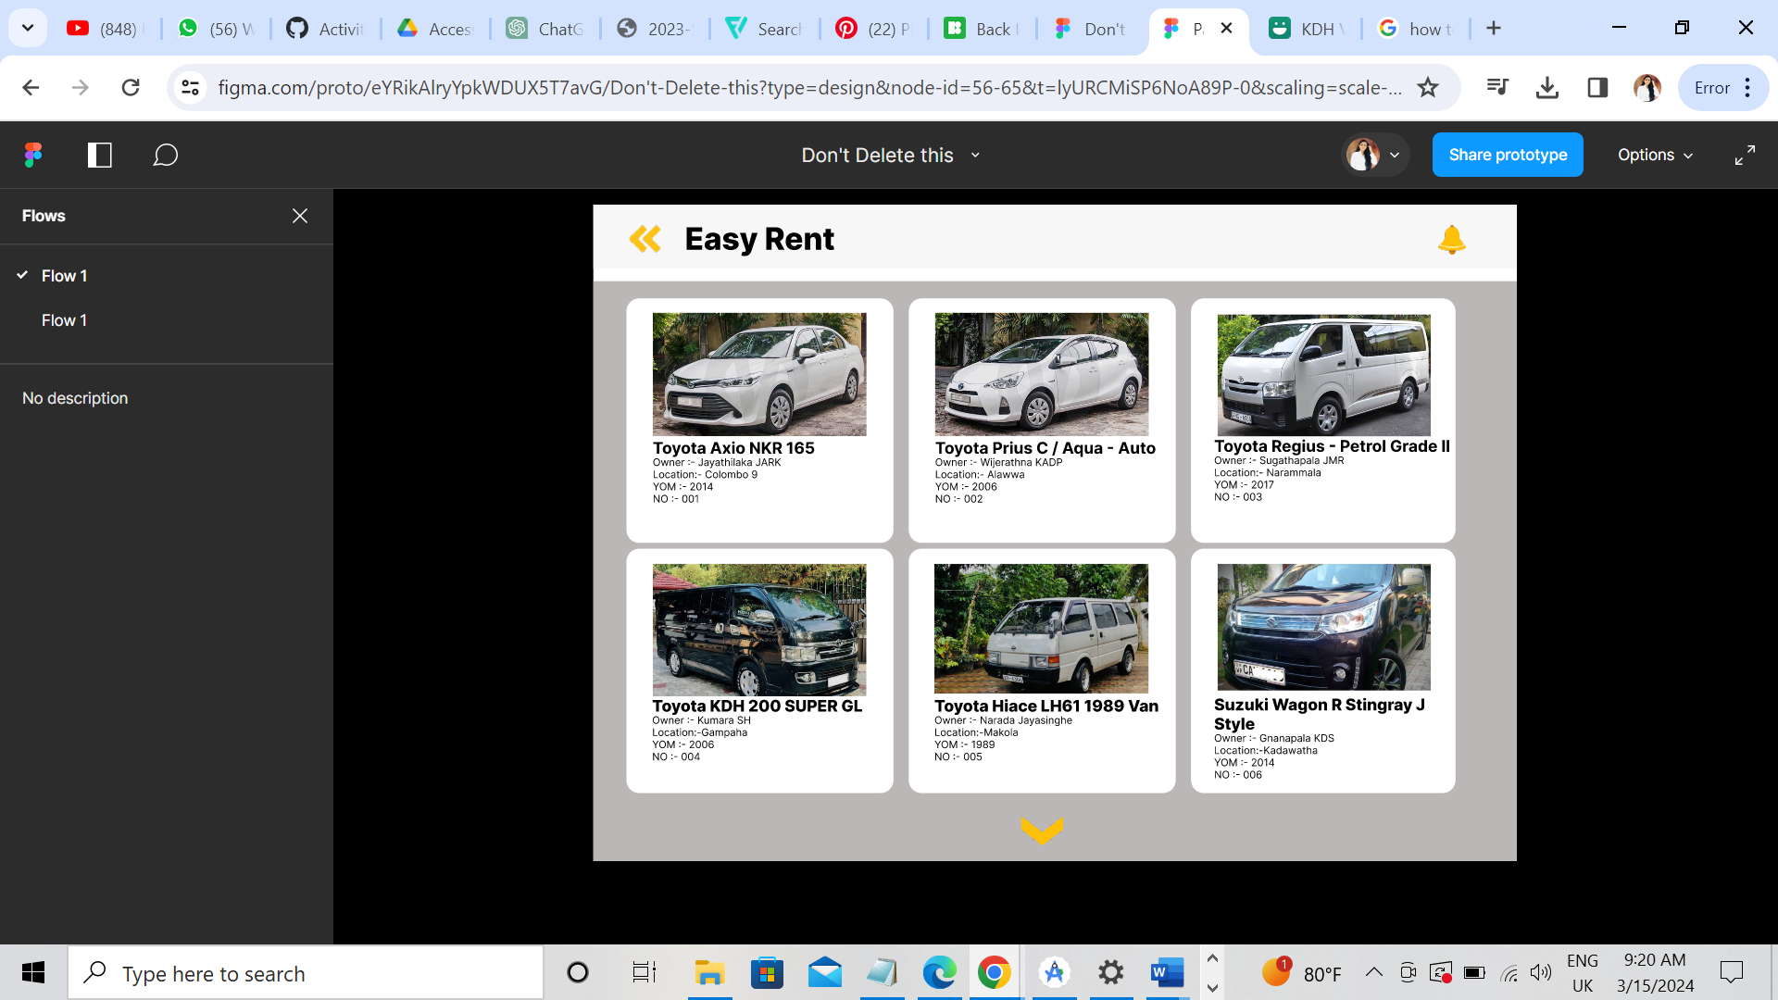

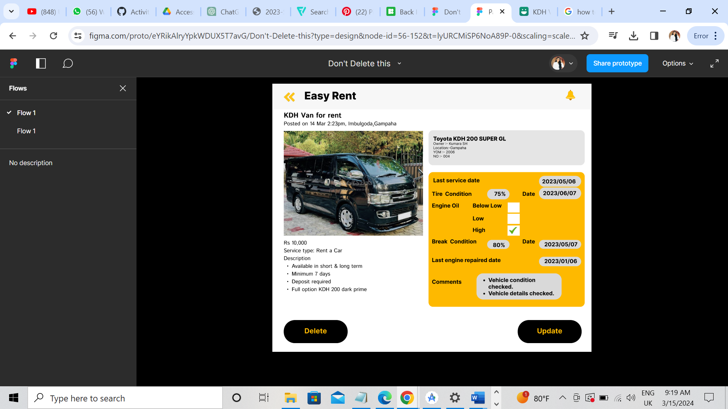

# HR Management

## Activity Diagram

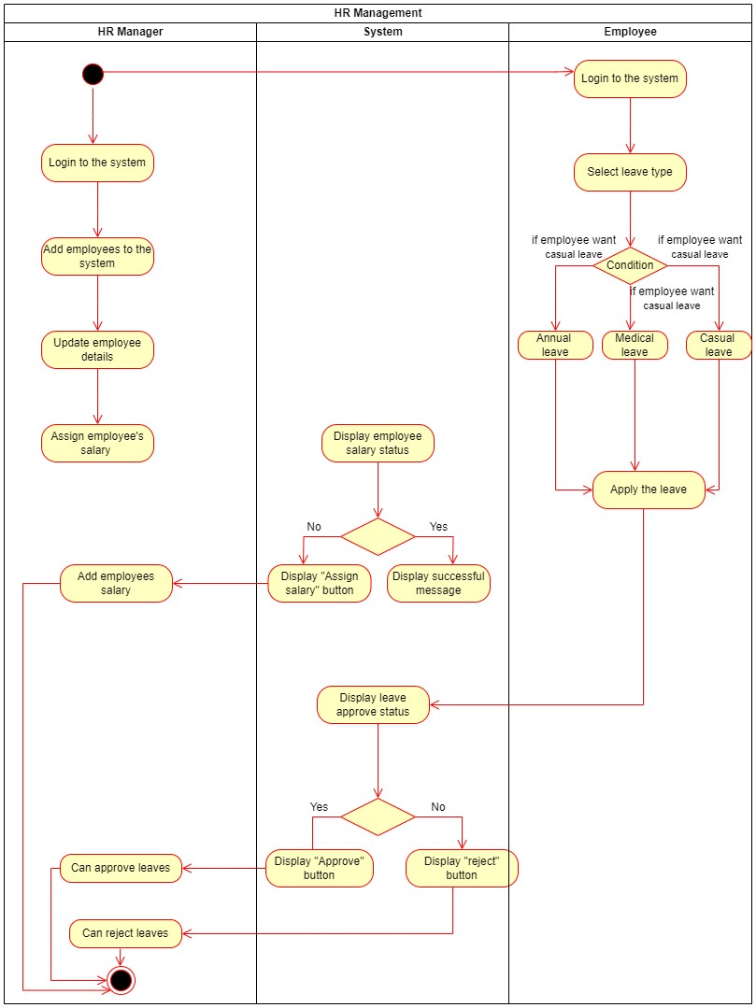

## User InterfaceA screenshot of a web page Description automatically generatedA screenshot of a computer screen Description automatically generatedA screenshot of a registration form Description automatically generatedA screenshot of a web page Description automatically generated

# System Maintenance

## Activity Diagram

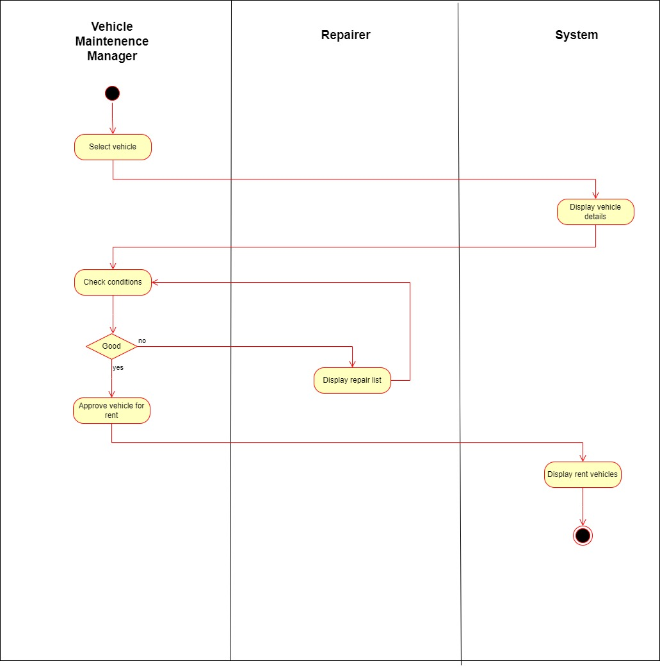

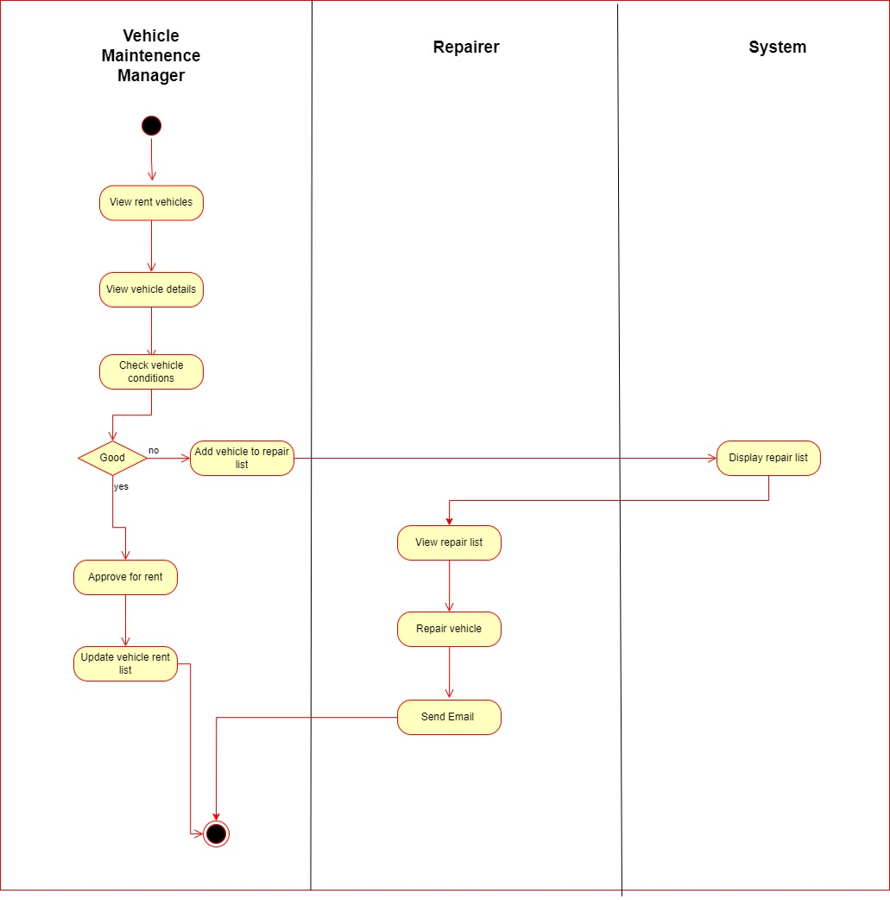

# System ER Diagram

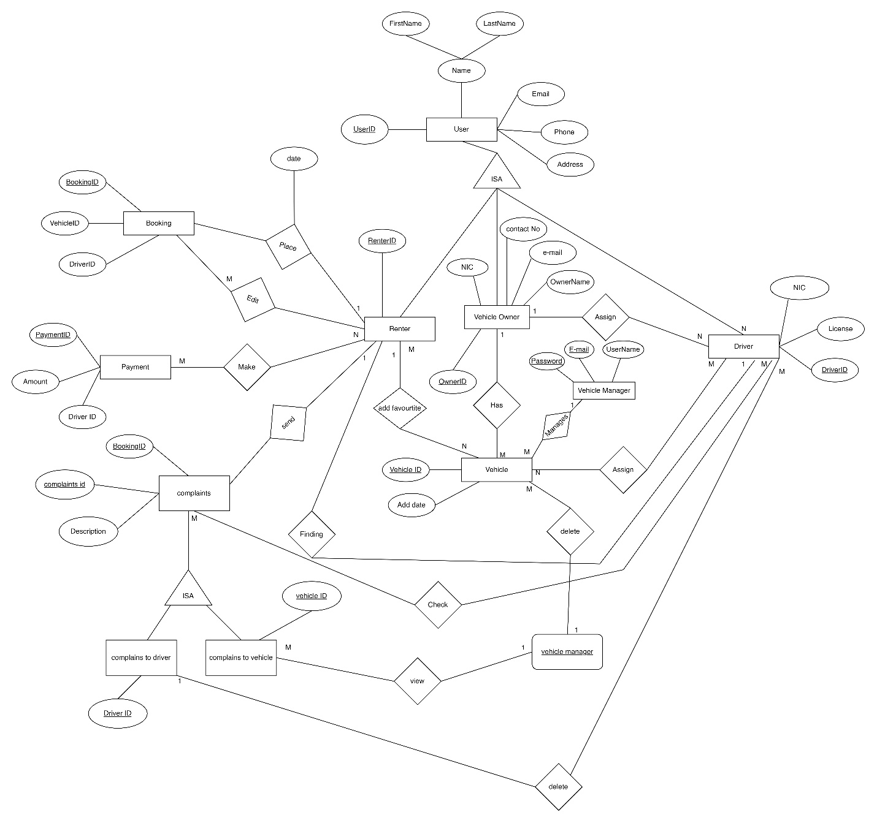

# System Class Diagram

